

Student Name: Leen Shareef Saleh

Student ID: 22110090

Instructor Name: Eng. Batool Al-Armouti

Course Name: Artificial Intelligence (AI) & Intelligent Systems

Topic: Final Report Submission of Implementing and Improving AI Systems

In completion of the requirements for passing the Artificial intelligence and Intelligent systems course

By Leen Shareef Saleh

Spring Semester 2023/2024

Introduction

1. The impact of AI to an area of application (of your choosing) including a description of Artificial Intelligence fundamentals and a description of the types and areas of application to solve current real word problem.

**Artificial Intelligence fundamentals**

Artificial intelligence may sound as a new concept for the past few years but in fact it’s origin date is since 1950 in which Alan Turing claimed that machines should be able to solve problems using reasoning and the information, just as how humans are capable of doing it.

This was the framework of his paper that was published in 1950 with the title of “COMPUTING MACHINERY AND INTELLIGENCE”

*Turing* *Test – Can machine think?*

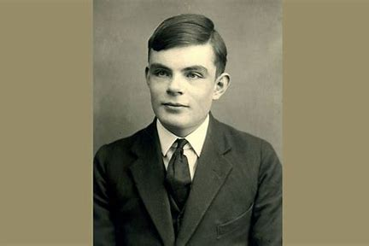

The Turing Test is like a game to see if a machine can talk like a human. Imagining we have three people: a judge, a human, and a machine. They are all in different rooms and can only talk through text on a computer screen. The judge's job is to figure out which is the human and which is the machine by asking them questions and reading their answers.

The point is, the judge does not know who is who. If the judge can't tell which is the human and which is the machine based only on the conversation, then the machine is considered to have passed the Turing Test.

* An interrogator must have 5 minutes conversations to decide if it is with program or real person.
* If the program fool the interrogator 30% of the time, it pass the test.

Alan Turing

**So now, Can the machine thinks?**

Firstly, for Alan Turing based on what was described before about Turing Test, he claimed that: “if a machine can engage in a conversation with a human in such a way that the human cannot reliably distinguish between the machine’s responses and those of another human, then we can consider the machine to be “thinking” or exhibiting intelligence.”

But for the modern perspective, complex tasks like image recognition, natural language understanding, and game playing can be accomplished by machine learning algorithms, neural networks, and deep learning models. And these algorithms operate based on patterns and statistical correlation rather than true understanding.

**This led us to identify what is Artificial Intelligence?**

To identify is to limit, when it comes to the concept of AI there will be so many perspectives and definitions but most of them are giving the concept of a machines that are capable of doing behaviors that would be intelligent behaviors if it was presented by humans. (even though from my perspective there is indeed mistake by using human intelligence or capabilities as a standard for Artificial Intelligence)

As a new concept and in simple terms, Artificial Intelligence is to develop a Algorithms and models that are capable of performing and doing tasks that historically required human intelligence, for example: reasoning, problem-solving, identifying patterns, learning, and decision-making.

**Neural Networks**

Neural networks are a key part of AI, especially in machine learning and deep learning. They are inspired by how the human brain works and are made up of layers of connected nodes (like tiny computers). These networks learn from data by changing the connections between nodes based on the mistakes they make, a process called training. The most advanced ones, called deep neural networks, have many layers between the input and the output, which helps them understand complex patterns and make accurate predictions. Neural networks are very important for tasks like recognizing images and speech, understanding language, and driving cars automatically.

**Types of Artificial Intelligence**

1. Artificial Narrow Intelligence (weak AI): This is mainly done by using the Natural Language Processing (NLP) concept. The NLP concept is a common feature of chatbots and related artificial intelligence domains, in which the machines are basically programmed to interact with humans by speech and text recognition techniques.

Example:

* Virtual assistant like Siri by Apple and Alexa by Amazon.
* For marketing and entertainment domains, tools for bringing the best recommendation based on search results, history, etc.…
* Self-driven cars.

1. Artificial General Intelligence (Strong or Deep AI):



The Human brain is the model implementation behind creating general intelligence. AGI is AI that can perform tasks that a human can perform. At this point, AGI is purely theoretical, but somehow it could replicate cognitive functions that humans have, such as language comprehension, perception, learning, reasoning, planning, imagination, creativity, social and emotional engagement, and problem-solving.

1. Artificial Super Intelligence: Basically, ASI is the imagined AI that not only interprets or recognizes human behavior and intelligence, but also the point at which machines develop the capacity to exceed humans in terms of intelligence and behavior. Superintelligence, a concept from science fiction, imagines machines becoming smarter than humans. They could excel in many areas like math, art, and even emotional understanding. While this sounds great, it also brings unknown consequences. Engineers are working on making computers as smart as humans, but we're not there yet. Some experts think it could happen soon, maybe even within this century. One big risk is that superintelligent machines might do "whatever it takes" to achieve their goals, which could be dangerous if they don't follow rules or consider consequences. So, we need to make sure we can control them if they ever become a problem.

**Artificial Intelligence – areas of application to solve real-world problems**

**HealthCare**

AI is getting more popular in different industries. In healthcare, experts think AI will not replace doctors soon. Instead, it will help them do their job better. Here are some common ways AI is used in healthcare:

1. **Performing Robotic Surgery:**

**AI is changing the way surgeries are done, especially with robots. It helps surgeons with things like measuring forces and detecting surgical margins. AI can even automate parts of surgeries. It's also improving surgical education by assessing skills and giving feedback. But using AI in surgery raises ethical questions that need careful consideration. Overall, AI is making big strides in robotic surgery and is seen as one of the most exciting advancements in recent years.**



1. Improving Medical Diagnoses: AI can help doctors find health problems by looking at medical images like X-rays, MRIs, and CT scans. It's good at spotting things like tumors and other issues, even early signs of diseases like cancer. Also, AI tools can help doctors make better diagnoses by looking at patient data and symptoms.



**The impact of AI to an area of application[1]**

**Hotel Industry**

* Personalization: Artificial intelligence (AI) systems examine visitor needs and behavior to provide specific dining, activity, and facility recommendations. And Hotels can improve the overall guest experience by anticipating their needs and offering customized offers through the use of Artificial Intelligence.
* Chatbots and virtual assistant: AI chatbots and virtual assistants are like 24/7 helpers for guests. They answer questions, book reservations, and give recommendations. These talking helpers make it easier for guests to communicate and make them happier overall.
* Fraud detection: AI looks at transaction data to find fraud, like unauthorized purchases or someone stealing your identity. Hotels use this to stop bad things from happening and keep your money and information safe.
* Smart Rooms Technologies: AI-powered smart room technology makes guests more comfortable and makes things more efficient with energy. Smart devices with AI can change things like temperature and lights in the room when guests ask or use their phone. Also, AI sensors watch how guests act and change room settings automatically to make them satisfied.

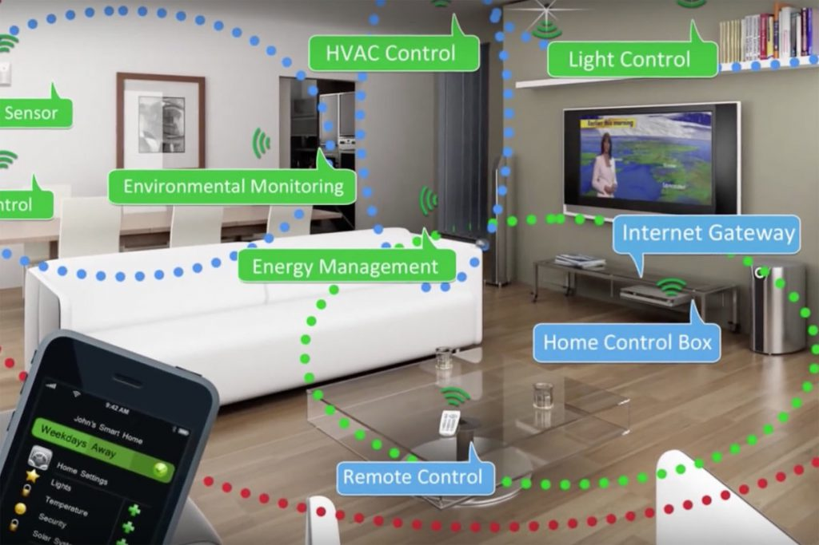

**Impact of AI in an era of application**

**Space Exploring**

1. **Astronaut Assistants: AI offers crucial support, like smart assistants for astronauts. These assistants, like Tars and Case (the** Interstellar movie**), help with tasks and monitor spacecraft conditions.**[2] **However,** These assistants are designed to understand and predict the requirements of the crew and comprehend astronauts’ emotions and their mental health and take necessary actions in the case of an emergency.[3]



* CASE’s specific tasks include data analysis, navigation, and supporting the crew in various ways.

1. Space debris solution[4]:



When satellites and spaceships don't return to Earth, they become space junk, which refers to any man-made debris left in space. This includes dead satellites and other objects left behind. The amount of space junk has become a critical problem because it poses a risk to active satellites and spacecraft. To address this issue, scientists are using deep learning to improve the accuracy of laser technology used to track space debris. By using neural network models, they can better pinpoint the location of debris, reducing the risk of collisions with active satellites and spacecraft. This advancement in technology could help prevent space accidents caused by collisions with space debris.

1. Analyze the advantages and disadvantages of using AI to the chosen area of application. (Hotel Industry)[5]

**Advantages**

1. Increased Operational Of Using AI And Productivity: With AI, businesses can streamline their operations and automate tasks, leading to increased productivity and better resource management. This reduces the likelihood of human errors, especially when handling customer data or managing spreadsheets. Marketing teams can benefit greatly from AI by using data insights to create targeted customer segments and run effective email and SMS campaigns. This automation saves time and allows staff to focus on more important tasks, ultimately driving better results for the business.
2. Improved customer experience: To keep customers coming back, it is important to make sure they have a great time whenever they interact with your brand. That is where AI comes in handy. With AI, businesses can make each customer's experience more personal and tailored to their likes and habits. What is more, AI can help connect all the ways a customer interacts with a brand online, making the whole experience smoother and more unified.
3. Better forecasting: In today's fast world, getting forecasts right and on time can make or break a business. AI can quickly analyze lots of customer data and find chances to make more money that might have been missed. Even better, AI can predict where the market is going, helping businesses plan better. With accurate forecasting, businesses can make smarter choices, use their resources better, and make more money in the end.

**Disadvantages**

1. Impersonal service: A big problem with AI is that it can feel cold and distant. Whether it's talking to a robot for customer service or using self-checkout machines, these experiences can make customers unhappy. AI can't replace the human feelings and understanding, which means there can be mistakes in how it helps people. Human interaction is really important for making customers feel special and keeping them coming back. It's the real connections with staff that make a place feel welcoming and keep customers coming back again and again.
2. System Failure: Running a hospitality business is tough because many things need to work well together. If something goes wrong, like double-booking rooms or losing orders, it can mess up everything. Customers might have to wait a long time, which makes them unhappy and leads to bad reviews. To avoid this, hospitality businesses need a plan for when their AI systems stop working. Being ready for problems helps them keep customers happy and the business running smoothly.

Bottom-up Approach

1. Investigate bottom-up approaches (techniques and tools) for modern intelligent systems deployment and compare the advantages and disadvantages of these techniques and tool.

This type of AI is all about learning and getting better without someone having to specifically program it. It's like teaching a machine to learn from its experiences.

Bottom-up AI is a different approach. It focuses on adapting and acting more like real life. It starts with simple things and builds up to more complicated ones. Instead of following strict rules, it's more about how things interact with each other and the world around them. This kind of AI tries to mimic how our brains work and how we learn from our surroundings. It's like starting from the basics and gradually getting more advanced.[6]

* Extract rules from data.
* Start with individuals.
* Create more sophisticated behavior.
* Learn appropriate responses to any given situation.[7]

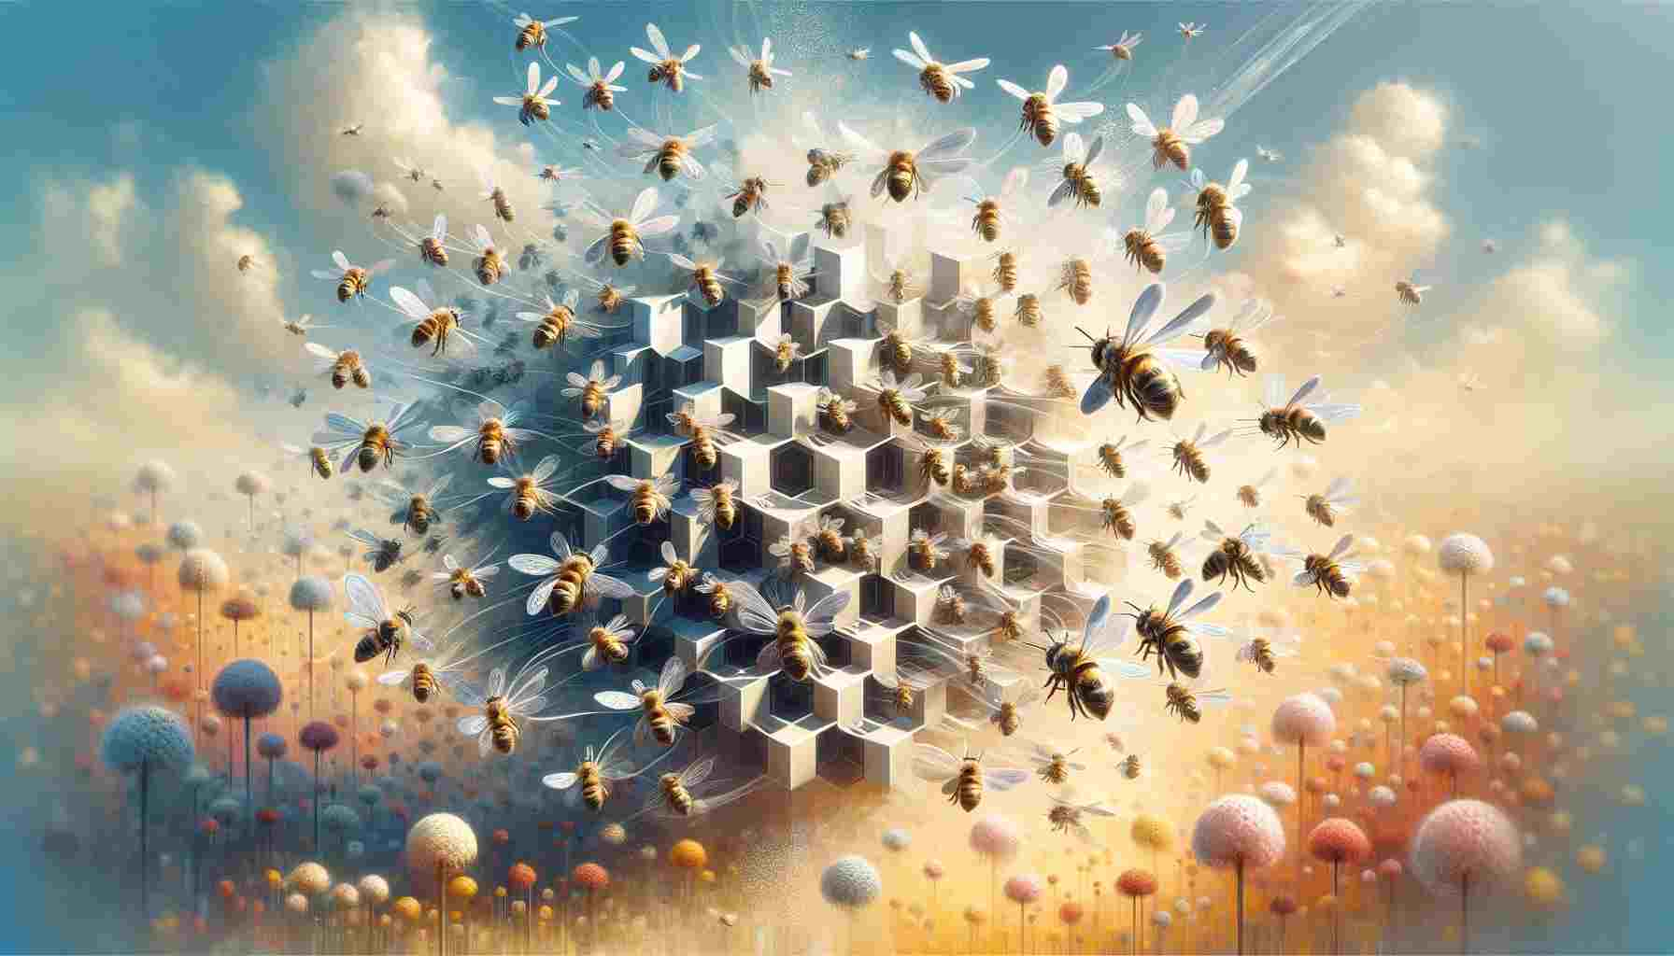

**Techniques and Tools**

1. *Swarm Intelligence*:[8]

“Groups are smarter when thinking together than the individuals would be on their own”

Combining the power of many minds into one.

Making predictions, asking questions, reaching decisions.

Simply Swarm is a **Brain of Brains**.

In SI systems, there are usually many simple agents, often called "boids," that interact with each other and their surroundings locally.

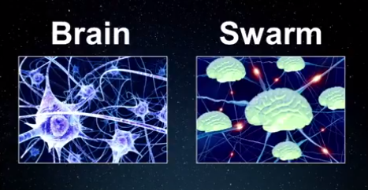

A brain is a system of neurons, so it can deeply connect and perform in an intelligent form, on the other hand, a swarm is a system of brains so deeply connected.

1. *Evolutionary Algorithms: [9]&[10]*

draws inspiration from biological evolution, First, imagining we have a problem, like figuring out the best way to do something. EAs start by coming up with a bunch of random ideas to solve the problem. These ideas are like the seeds of a plant.

Then, a fitness function checks how good each idea is at solving the problem. It's like grading each idea to see if it's helpful or not.

Next, the best ideas get to "reproduce" by making slight changes to themselves. It's kind of like mixing and matching different traits from different ideas to see if they make something even better.

EAs can be used in lots of different areas, like finance, engineering, healthcare, games, art, robotics, and machine learning. They're good at adapting to different kinds of problems and exploring lots of different ways to solve them. But sometimes, they can take a long time to find the best solution because they have to check so many possibilities.

*Genetic Algorithm[11]*

Genetic Algorithms (GAs) are a type of evolutionary algorithm used to solve optimization problems. Solutions are represented as chromosomes, typically strings of binary digits, with each chromosome corresponding to a potential solution. Starting with a random population of chromosomes, GAs use a fitness function to evaluate each solution's quality. Selection mechanisms choose parents for reproduction based on their fitness, and offspring are created through crossover and occasional mutation. The offspring replace some members of the old population, and the process continues for a fixed number of generations or until a stopping criterion is met. GAs have diverse applications, including image processing, vehicle routing, and software engineering. Challenges include parameter tuning and scalability, but researchers have developed various GA variants to address these issues. Overall, GAs provide a powerful approach for exploring solution spaces and finding optimal or near-optimal solutions in complex scenarios.

*Advantages and disadvantages of Swarm and Evolutionary Algorithms [12]*

|  |  |  |
| --- | --- | --- |
| Algorithm name | Advantages | Disadvantages |
| Swarm Algorithm[13] | Swarm intelligence can make cool things happen unexpectedly when the situation changes, which is great for places where things are always changing. | It's hard to figure out why swarm systems make certain decisions because each agent kind of does its own thing, which can be confusing. |
| Instead of one brain doing all the work, swarm systems share the workload among a bunch of agents, making it easier to handle lots of stuff at once. | Keeping track of all the interactions between agents can get really messy and might lead to some unexpected problems if we're not careful |
| Swarm-based systems can quickly adapt to new stuff without needing someone to boss them around, which gives them more freedom to deal with different situations. | While swarm intelligence works well for some things, it can struggle when things get really big or complicated, making it tough to handle everything smoothly. |
| Evolutionary Algorithm | Evolutionary algorithms try out lots of different ideas, which helps them find cool and creative solutions to tricky problems. | Evolutionary algorithms can hog up a lot of computer power because they have to check so many different possibilities. |
| They're good at rolling with the punches and adapting to changes in the problem, which makes them handy for situations where things keep changing. | Sometimes, how well they work depends on how we set them up, and if we don't get it right, they might not work as well as they could. |
| Evolutionary algorithms can work together on different parts of the problem at the same time, which speeds up the process when we have lots of things to figure out. | They don't always find the absolute best solution, so they're better for coming up with good ideas rather than finding the perfect answer. |

*And one other technique is neural network:*

Neural networks are a key part of artificial intelligence that work similarly to the human brain. They consist of layers of interconnected nodes, or neurons, where each connection has a weight that gets adjusted during training. The basic idea is that these networks learn to recognize patterns by processing large amounts of data. For example, a neural network can learn to identify images of cats by analyzing thousands of cat photos, adjusting the weights based on how well it predicts whether each image is a cat or not.

In a neural network, the data moves from the input layer, through one or more hidden layers, to the output layer. Each layer extracts different features from the data, with the initial layers focusing on simple features like edges or colors in an image, and the deeper layers recognizing more complex patterns like shapes or objects. This "bottom-up" approach means the network builds its understanding from simple to complex, gradually improving its ability to make accurate predictions or decisions. This way, neural networks can be trained to perform a wide variety of tasks, from recognizing speech to translating languages to driving cars autonomously.

Neural networks have several advantages. They are excellent at recognizing patterns and making predictions, which makes them ideal for tasks like image and speech recognition, language translation, and even playing games. They can learn and improve over time as they process more data, becoming more accurate and efficient. Additionally, they can handle large amounts of data and complex relationships between data points, which is challenging for traditional algorithms.

However, neural networks also have some disadvantages. They require a lot of data and computational power to train effectively, which can be expensive and time-consuming. They are often seen as "black boxes" because it can be difficult to understand how they make decisions, which raises concerns about transparency and trust. Additionally, they can be prone to overfitting, where they perform well on training data but poorly on new, unseen data, requiring careful tuning and validation.

Tools:

|  |  |  |
| --- | --- | --- |
| **Tool Name** | **Advantages** | **Disadvantages** |
| **PyTorch** | Easy to debug and experiment with because of the dynamic computation graphs. | Historically less mature for deployment, though it's getting better. |
| Intuitive and beginner-friendly, integrates well with Python libraries | Slightly less efficient for some large-scale tasks compared to TensorFlow. |
| **TensorFlow** | Flexible and scalable, supports many platforms like CPUs, GPUs, and TPUs. | Can be complex and harder to debug than PyTorch. |
| Strong ecosystem for production, including mobile and web support. | Steeper learning curve for beginners. |
| **Keras** | User-friendly, makes building and training models easy. | Limited flexibility for complex, customized models. |
| Can run on top of TensorFlow, Theano, or CNTK. | Not ideal for advanced model architectures and operations. |
| **Microsoft Cognitive Toolkit** | High performance, great for large-scale deep learning tasks. | Smaller community and less documentation compared to TensorFlow and PyTorch. |
| Supports both deep learning and traditional machine learning. | Less intuitive for beginners, harder to integrate with other tools. |

**Additional tools:**

MASON and NetLogo are tools for making simulations where many small parts work together. MASON is very flexible and great for detailed simulations, but it can be hard to learn and uses Java, which some people might not know. NetLogo is easier to use and good for learning, with lots of helpful libraries and a friendly community. However, it doesn't work as well for very big projects and doesn't easily connect with other programming languages.

1. Develop an intelligent system using a bottom-up approach (as a proof of concept).

Provided by GoogleColab File.

1. Test the system and analyze the test results.

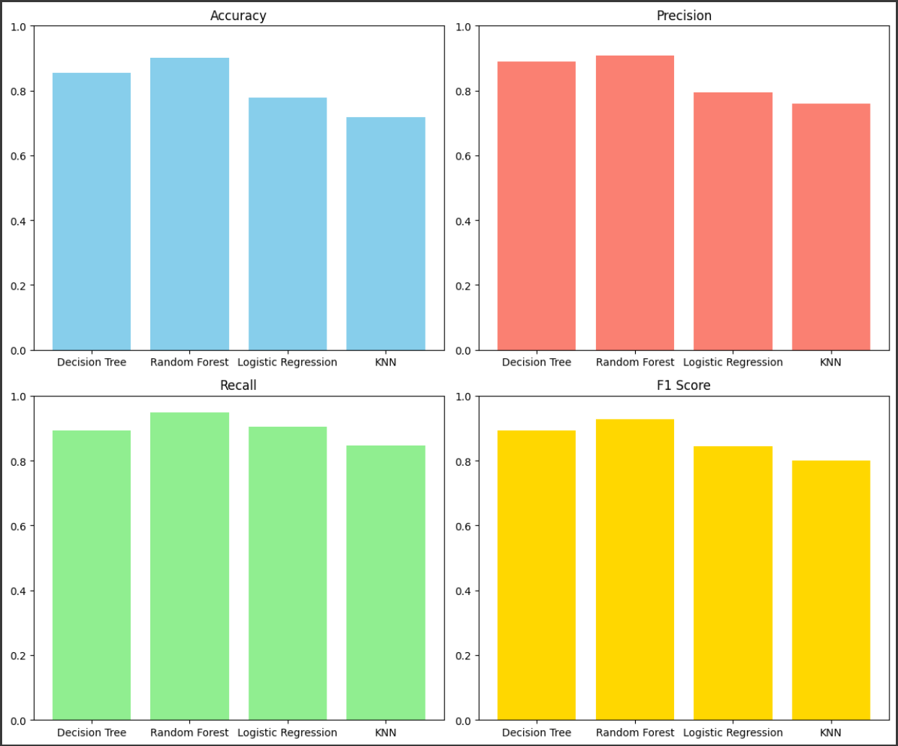

*Analyzing the results:*

- KNN Classifier had the lowest accuracy at 71.78%, indicating its weaker performance in predicting correct outcomes.

- KNN also showed lower precision and F1 score compared to other models, implying it struggled more to accurately identify positive cases.

- Random Forest Classifier emerged as the top performer with the highest accuracy, precision, recall, and F1 score.

- Random Forest's balanced performance makes it a suitable choice for the classification task, offering the best overall predictive capability.

1. Modify the system to enhance performance and demonstrate the technical modification to the system using the initial results as benchmark for the performance.

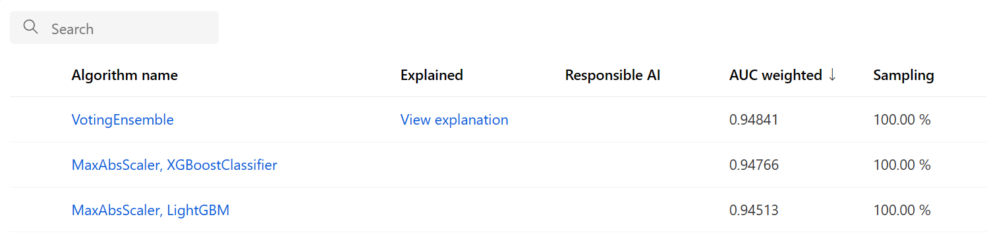

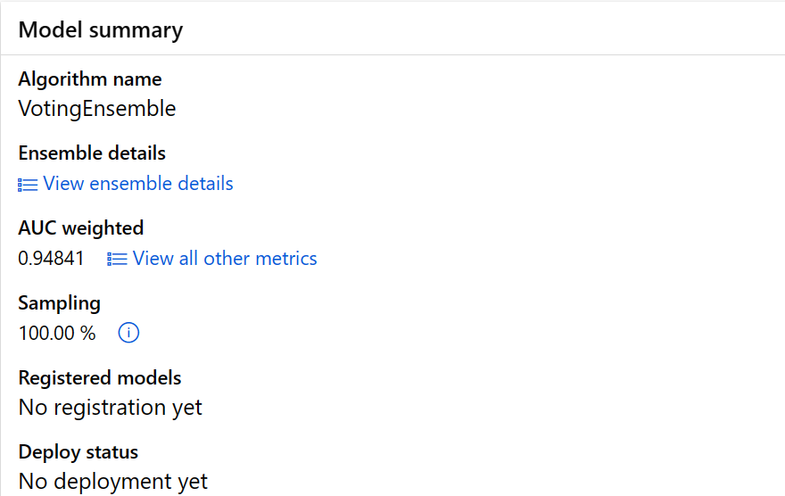

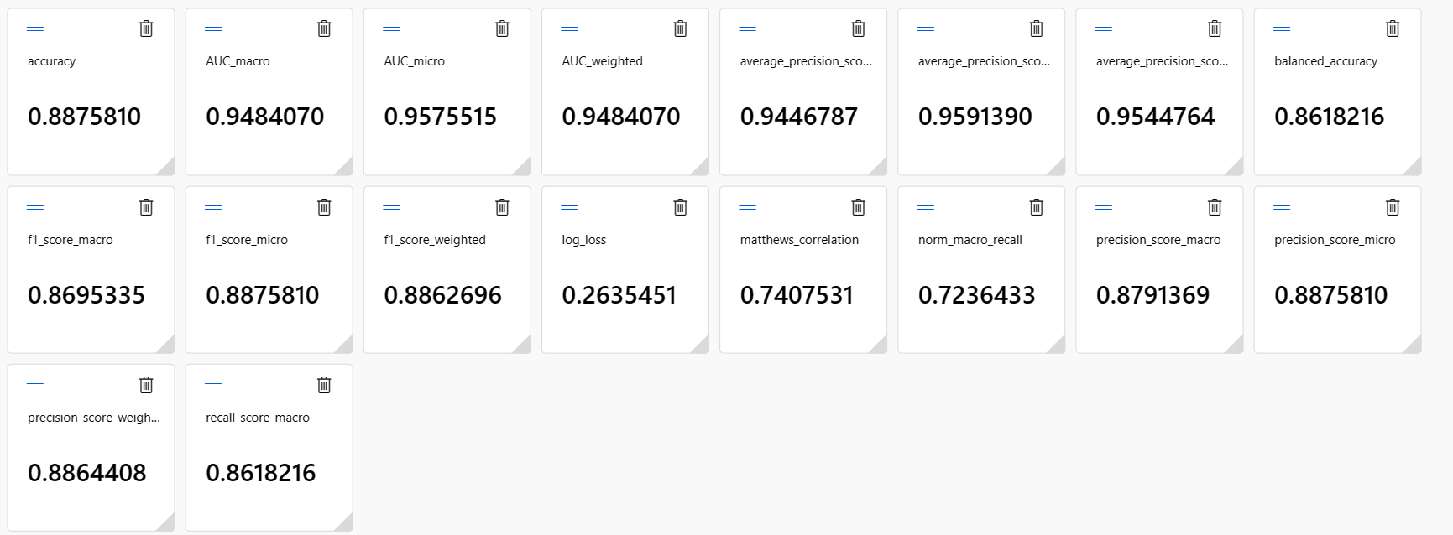

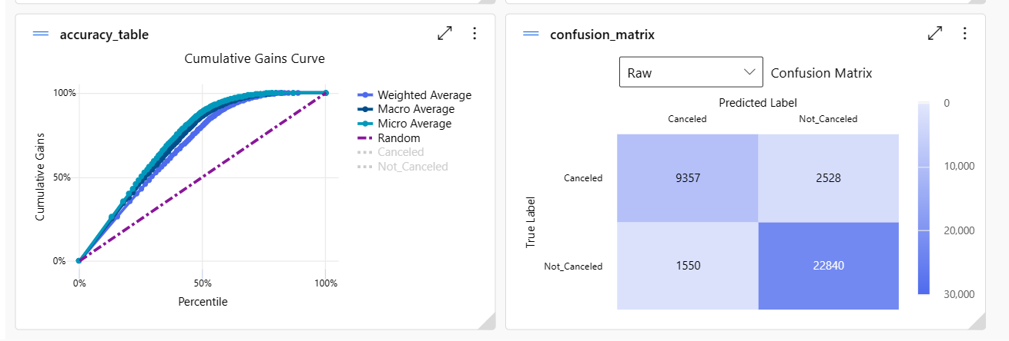

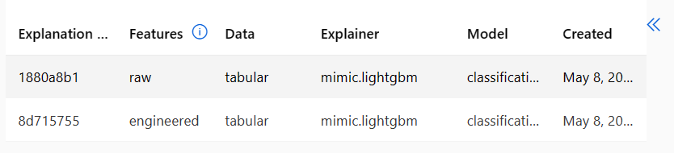

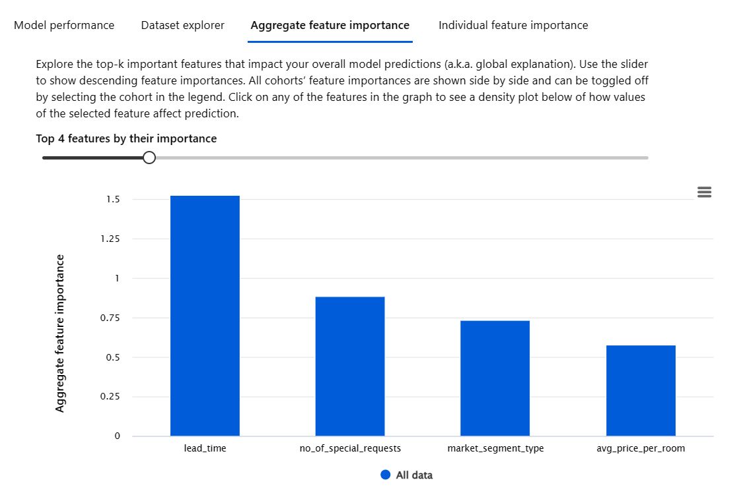

1. Deploy the system using Microsoft Azure ml studio as a service (provide a screenshot of the deployment status and endpoint details).

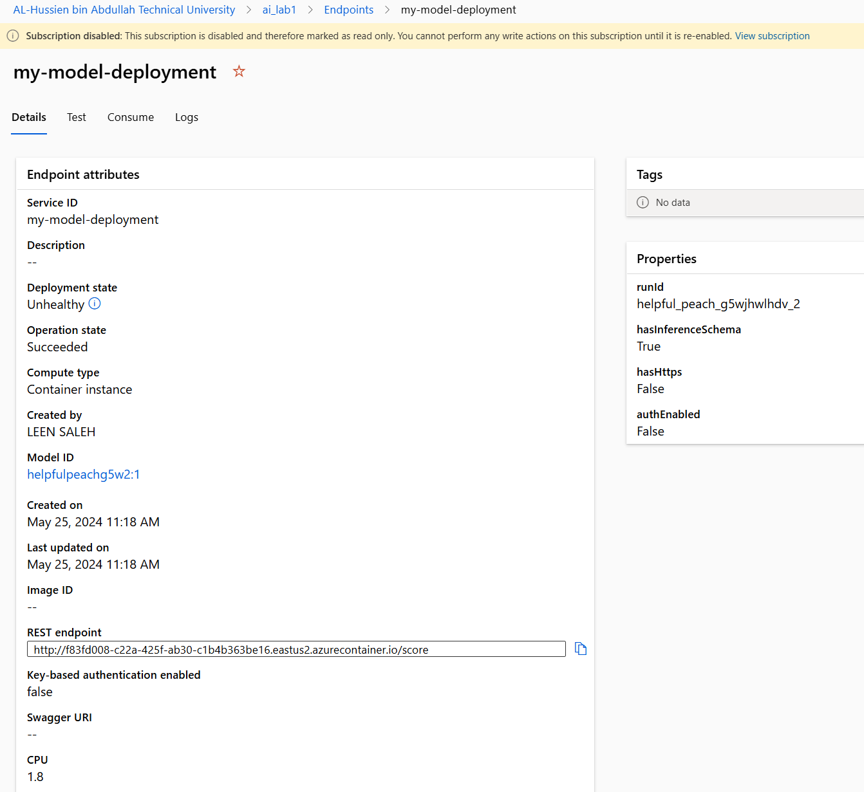

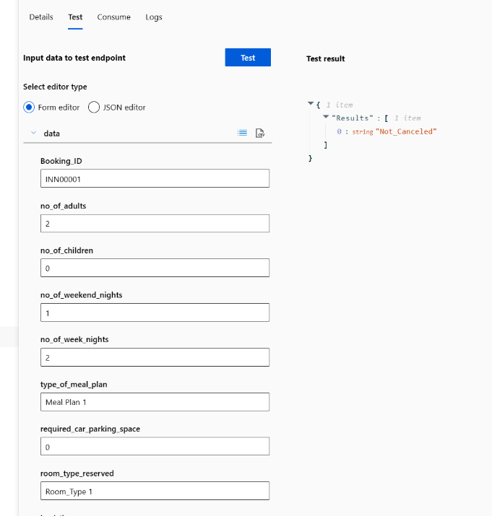

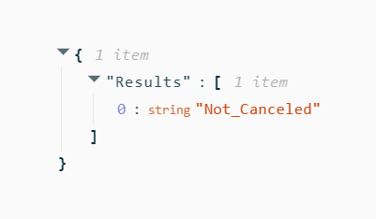

1. Evaluate your own role to improve the performance of an AI-based system.

My role in improving an AI-based system involves carefully choosing the right dataset, selecting the best machine learning models by building some models and comparing their results, and evaluating their performance. Using Python's tools like sklearn, testing different models to find the most effective one. By tuning parameters and assessing metrics like accuracy and precision, I refine the models further. With Azure's platform, I deploy the top-performing model (VotingEnsemble), ensuring it's reliable and scalable by deploying process and testing. This ongoing process helps me continually enhance the system's accuracy and efficiency to meet evolving needs.

Choosing the right models was a big part of my job. I tried out different AI models like K-Nearest Neighbors (KNN), Decision Tree, Reinforcement Learning, and Logistic Regression to see which one worked best for the hotel industry. I made sure to fine-tune these models to make them more accurate and effective. This testing and adjusting were important to get reliable and useful predictions.

Using Microsoft Azure was very helpful. Azure's tools made it easier to pick and improve the best models quickly. It also helped the models handle large amounts of data as the hotel gathered more information. Azure's advanced features were key in making sure the AI models performed well and could grow with the hotel's needs.

Managing the code with MLflow was another important task. MLflow let me keep track of different versions of our models and experiments, showing what changes made the models better. This tracking made it easy to reproduce results, which is important for keeping the system working well over time.

Making data preparation simple was also crucial. I made sure the data we used for training and testing was clean and consistent. This meant fixing errors, filling in missing values, and standardizing formats to keep the data accurate. I also focused on the most important data features that affected the AI models, making them more effective by using the most relevant information.

1. Critically evaluate the effectiveness of the chosen method and suggest methods of improvement. (compression between python and azure)

The Random Forest classifier proved to be very effective in predicting hotel reservation cancellations. It achieved the highest accuracy among the models tested, meaning it correctly predicted customer cancellations more often than others. Additionally, it outperformed other models in terms of precision, recall, and F1 score, showing its capability to accurately identify both cancellations and non-cancellations. The ensemble nature of Random Forest makes it resistant to overfitting and able to handle various data patterns, which contributed to its strong performance.

However, there are some limitations to using the Random Forest classifier. One major drawback is that it can be computationally intensive, especially when using a large number of trees. This can slow down both training and prediction times. Another limitation is interpretability; while Random Forests provide good performance, they can be harder to interpret compared to simpler models like Decision Trees or Logistic Regression.

Using Azure Machine Learning Service can help with scalable and efficient hyperparameter tuning through automated machine learning (AutoML) to find the best model settings. It also supports feature engineering and data preprocessing to improve the dataset. For model deployment and monitoring, Azure provides a robust infrastructure to deploy top-performing models, ensuring they are reliable and scalable. Additionally, Azure Monitor can track the performance of these deployed models in real-time, allowing for continuous improvement and quick identification of any issues.

To improve the performance of the Random Forest model, several strategies can be implemented. First, enhancing feature engineering is important. Creating new features that capture more information, such as customer behavior patterns and booking lead time, could give the model more predictive power. Using the feature importance scores from Random Forest can help identify and focus on the most influential features.

Combining multiple models, through techniques like stacking or blending, can also improve predictive performance by leveraging the strengths of different models. Advanced hyperparameter optimization techniques, such as Grid Search or Random Search, can be used to fine-tune the model parameters further. Azure's AutoML can assist in automating this process efficiently.

Implementing stratified cross-validation ensures that each fold of the dataset has a similar distribution of the target variable, leading to more reliable performance estimates. Repeated cross-validation can also provide a more robust estimate of the model’s performance.

Setting up a system for continuous learning and model updating ensures that the model remains accurate as new data becomes available. A monitoring system to track the model’s performance in production and gather feedback can help identify areas for further improvement.

Top-down Approach

1. Investigate top-down approaches (techniques and tools) for modern intelligent systems deployment and compare the advantages and disadvantages of these techniques and tool.

In the top-down design model, we start with a big picture of the system without diving into details. Then, we break down each part into smaller, more detailed pieces until we have a complete and detailed plan.[14]

For example, think about creating a program for a university or a word processor. These are big and complex tasks. But using the top-down approach, we break them into smaller tasks, and then break those tasks into even smaller ones until each piece is manageable.

**Advantages of this approach include**:

- It helps us figure out what needs to be done by breaking the problem into smaller parts.

- As we refine each step, the parts become less complex and easier to handle.

- Some parts of the solution might be usable in other projects.

- Breaking the problem into parts means more than one person can work on solving it.

**Disadvantages:[15]**

* Missing Details: Starting from the top can make things too simple, and important details might be missed, which can hurt how well the system works.
* Assumptions and Generalizations: Decisions made at a high level often rely on guesses and broad statements that might not be true in every situation.
* Team Resistance: Some team members might feel left out of the decision-making process, which can lower their morale and involvement.

Techniques and tools:[16]

1. Expert Systems:

* Expert systems simulate a human expert's ability to make decisions. To draw conclusions, they employ a body of knowledge and a set of rules.
* Tools: CLIPS, Prolog, Jess.

1. Rule-Based systems:[17]

* These systems use an established set of rules to solve issues and make decisions. They are straightforward and easy to understand.
* Tools: Drools, IBM Operational Decision Manager.

1. Hierarchical Task Network (HTN) Planning:

* Tasks are divided into smaller tasks in a hierarchical fashion during HTN planning. This methodology is extensively employed in robotics and automated planning.
* Tools: SHOP2, JSHOP.

**Advantages and Disadvantages:[18]**

|  |  |  |
| --- | --- | --- |
|  | Advantages | disadvantages |
| Expert systems | mimic human reasoning and produce excellent results.  dependable and consistent after the knowledge base is complete.  beneficial in fields with an absence of expert knowledge. | Learning can be challenging and time-consuming.  Flexible rule sets may not work well in new or undefined situations.  As the knowledge base expands, updates and maintenance may become more difficult. |
| Rule-based systems | Efficient and logical; simple to use and understand  Extremely transparent, allowing for simple decision-path tracking.  adaptable in fields with precise and well-established regulations. | Problems with scalability when rules increase.  Not adaptable; finds it difficult to function in complex or dynamic environments.  Unintentional interactions between rules can make maintenance challenging. |
| Hierarchical Task Network (HTN) Planning | divides difficult jobs into smaller, more doable tasks.  efficient for robotics and autonomous systems scheduling and planning.  gives the actions a clear structure and order. | In-depth domain knowledge is necessary to define tasks and subtasks.  can be costly to compute when dealing with large and intricate hierarchies.  less successful in situations that are extremely unpredictable or dynamic. |

Top-down approaches in AI provide organized and dependable methods for setting up smart systems, especially in areas needing high accuracy and expert knowledge. Techniques like expert systems, rule-based systems, HTN planning, ontologies, and formal methods each have their own benefits and difficulties. By knowing the pros and cons of these approaches, organizations can pick the best methods and tools for their specific needs and limitations.

tools like IBM Watson, Google Cloud AI, and Amazon SageMaker, AI can still be used in a top-down approach, but they would be selected based on how well they align with the overall objectives and requirements of the project.

|  |  |  |
| --- | --- | --- |
| Tools names | advantages | disadvantages |
| IBM Watson | Offers a suite of AI services for natural language processing, image recognition, and more. | Requires familiarity with IBM Cloud platform for deployment and management. |
| Google Cloud AI | Provides pre-trained machine learning models and APIs for various tasks like vision and speech recognition. | May have limitations in customization for specific use cases. |
| Amazon SageMaker | Offers end-to-end machine learning workflows, including data labeling, model training, and deployment. | Requires familiarity with AWS ecosystem and services. |

1. Develop a chatbot to support the bottom-up approach using top-down approach.

**Explanation of the development**

This is a simple hotel booking chatbot made in Python. Here's how it works: It starts by saying hi and tells you what to do. Then, it waits for you to type something. If you type 'hi' or 'hello', it greets you and gives you choices. If you type '1', it helps you book a room. If you type '2', it gives you information. If you type '3' or 'quit', it says bye and stops. If you book a room, it asks for details like the date, type of room, meal plan, parking, and any special requests. Then, it confirms your choices and says it will process your booking. If you type something it doesn't understand, it asks you to start again or quit. When you're done, it says goodbye and finishes. This chatbot is like talking to a helpful person who arranges hotel stays for you.

Note: the file is uploaded to e-learning.

1. Test the system and analyze the test results.

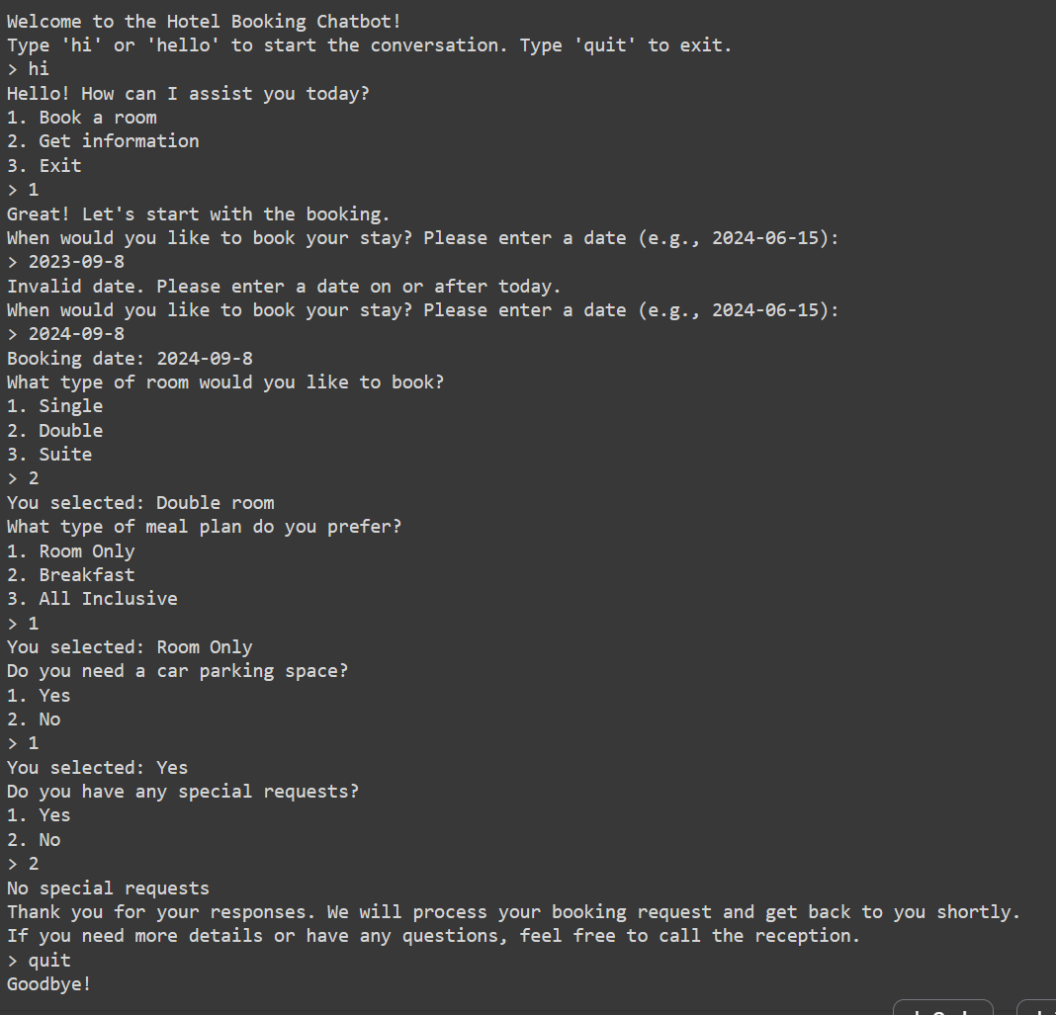

Analysis:

* The chatbot responded correctly to the user inputs in all scenarios.
* It provided appropriate prompts and guidance for each action the user could take.
* It successfully handled various inputs, including commands, dates, choices for room type, meal plan, parking, and special requests.
* The chatbot terminated correctly when the user decided to exit.

The chatbot starts with clear instructions, allowing users to navigate easily. It operates smoothly within a loop, ensuring uninterrupted interaction until the user decides to exit. When users greet the chatbot with 'hi' or 'hello', it offers options: booking a room, getting information, or exiting. This empowers users to choose their preferred path. During booking, the chatbot guides users effectively, prompting them for necessary details and handling invalid dates gracefully. It also provides helpful information, like the reception phone number for further assistance. However, clearer instructions and improved error handling could enhance the user experience. Overall, the chatbot effectively assists users in booking and accessing hotel information. Simplifying instructions and refining error handling could further improve user satisfaction.

1. Critically evaluate the effectiveness of the chosen method and suggest methods of improvement.

To make the hotel reservation chatbot better, we can focus on a few key things. First, let's make sure it talks in a friendly way to users. That makes booking a room more fun. Second, if someone makes a mistake when typing, the chatbot should help them understand what went wrong. Third, it needs to check if dates and other info are right so there aren't any mix-ups. Fourth, it can remember what users like, so booking is quicker next time. Also, connecting it to the hotel's booking system means it can tell users right away if there's a room available. Lastly, letting users give feedback helps make the chatbot even better over time. By doing these things, the chatbot can be easier and more helpful for people booking hotel rooms.

**Effectiveness:**

The chatbot effectively assists users with hotel bookings and provides relevant information in a structured manner. Its clear instructions and user-friendly interface facilitate easy navigation, ensuring a smooth booking process. By utilizing the local date to validate user input, the chatbot enhances accuracy and reliability, preventing users from selecting invalid dates. Additionally, the chatbot's graceful handling of invalid inputs contributes to a positive user experience, allowing users to correct errors seamlessly. Moreover, the inclusion of the reception number for further assistance demonstrates a proactive approach to addressing user needs beyond the chatbot's capabilities.

**Improvements:**

Despite its effectiveness, there are areas where the chatbot could be further improved to enhance user satisfaction. Providing more comprehensive guidance, particularly for complex tasks like entering booking dates, would enhance user understanding and confidence. Additionally, refining error handling by offering specific suggestions or examples for corrections would streamline the interaction and reduce user errors. Furthermore, integrating additional features such as real-time room availability checks or detailed descriptions of hotel amenities would enrich the chatbot's functionality, providing users with a more comprehensive booking experience.

By implementing these improvements, the chatbot can continue to evolve as a valuable tool for hotel booking and information retrieval, enhancing user satisfaction and usability.

Intelligent Systems Deployment

1. Discuss how your implementation of different AI approaches to work together for the deployment of intelligent system.

Deploying smart systems in hotels is really important for making customers happier, running things smoother, and making more money. In this report, we talk about using different AI tools like K-Nearest Neighbors, Logistic Regression, randomForst, and Decision Trees to make a system for hotels and determining if the clients are going to cancel their reservation or not. Also, we look at how Microsoft Azure helps pick the best models and MLflow helps manage the code. Plus, we check out how adding a chatbot can help get feedback from customers and make them even happier. we train our models to understand the patterns in our data. Once we have trained our models, we need to check how well they're doing. By using a mix of KNN, Logistic Regression, Random Forest, and Decision Trees throughout the process, we can build strong, effective systems for predicting reservation cancellations and making guests happy.

Microsoft Azure for selecting the best model: Microsoft Azure has a bunch of tools to help with AI stuff. With Azure, we can easily pick the best models and make them work better. This helps hotels use really good models for their needs.

And one other point that its worth mentioning, the deployment of the system was accurate

MLflow: MLflow helps us keep track of our machine learning from start to finish. We use it with our Python code to make sure everything goes smoothly. This makes our intelligent systems more reliable and strong.

Chatbot: Adding a chatbot to our system lets us talk easily with customers. It helps us get feedback quickly, give personalized suggestions, and solve problems fast. The chatbot makes customers happier and more engaged with the hotel.

In our AI application for hotels, deploying smart systems is crucial for enhancing customer satisfaction, operational efficiency, and revenue generation. We utilize various AI tools such as K-Nearest Neighbors (KNN), Logistic Regression, Random Forest, and Decision Trees to create an effective system for predicting reservation cancellations and improving overall guest experience. Additionally, integrating a chatbot into our system facilitates seamless communication with customers, allowing for quick feedback collection, personalized recommendations (when linking the predictive models and the chat bot we build a comprehensive system ), and efficient issue resolution, ultimately leading to increased customer engagement and satisfaction. The client could book a room, check for reservations, and of he faces any other problems he could call the receptionist for a further assistant. Together, these components work synergistically to create a comprehensive AI application that benefits both hotels and their guests.

1. Evaluate the potential impact of deploying Intelligent Systems on users and organization (belonging to the chosen area of application).

Introducing smart systems in hotels can make a big difference for both guests and the hotel itself. For guests, these systems can make their stay even better by giving them personalized suggestions, quick help from chatbots, and easier booking.[19] Guests might get recommendations for things like food and activities that match what they like, making them happier and more likely to come back. Also, these systems can help guests talk to hotel staff faster and sort out any issues they have, making their experience smoother.[20]

For the hotel, smart systems can bring lots of benefits too. They can take care of everyday tasks like managing bookings and assigning rooms, freeing up staff to focus on more important stuff. Plus, these systems can give the hotel useful information about what guests like and want, so they can offer better services and promotions. They can even use fancy math to predict if someone might cancel their booking or figure out the best prices for rooms, helping the hotel make more money. Overall, using smart systems in hotels could change how hotels and guests interact, make things run better, and lead to more success for everyone involved.[21]

As well as there are a lot of benefits of deploying AI systems, there could be a group of challenges and risks:

1. Getting hotel staff used to new technology can be tricky. They might need training to understand how to use these systems properly, and that can take time and money. Also, some staff might not like change or might find it hard to learn new things, which could cause problems. If staff aren't trained well, it could lead to mistakes or unhappy guests.
2. Making sure guests' personal information is kept safe is really important. Smart systems use a lot of data, like names, contact information, and booking history. If this data isn't protected well, it could cause big problems. For example, if a hotel's smart system gets hacked, guests' private information could be exposed, which would be really bad for the hotel's reputation.

To understand these challenges better, let's imagine a hotel that uses a smart system to recommend things to guests based on their past visits. If the system relies on biased data, it might end up favoring certain types of guests over others, which could make some guests feel left out or discriminated against.

Challenges and Opportunities

1. Discuss how AI changed the world in the last two decades by Investigating and evaluating the security, ethical and social issues of the developed intelligent system.

In the last twenty years, AI has changed the world a lot, and has made a huge changes in how industries operate. The hotel industry has changed a lot because of AI, making things more efficient, improving customer service, and helping manage operations better. These changes has a big effect on security, ethics, and how people interact with each other.

As Artificial Intelligence benefits in a lot of areas and as it is moving out of the research labs into the real world, with more and more people becoming aware of some ethical concerns that can come along with some of these applications.

So there are 3 big ethical concerns with artificial intelligence, the first one is **what we actually use AI for?** It could be using video tracking of people in Healthcare settings to make sure that they are recovering from an injury, but the same technology can be taken out and put into smart bombs to track people.

So we need to figure out when we are developing AI algorithms what are the potential outcomes that we do not expect.[22]

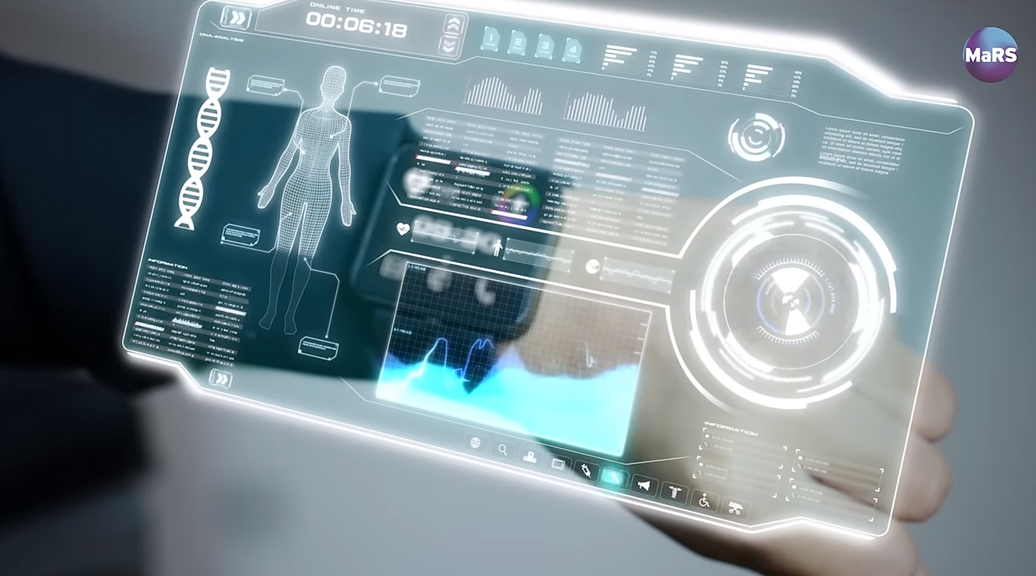

video tracking of people in Healthcare



smart bombs that track people.

The second concern is **who has access to AI?** increasingly AI has to run on bigger and faster and more expensive machines and the only people how can afford those machines these big international companies, which means that a fewer and fewer people are actually can control the destiny of AI. But we do not want that, we want all people to know how AI can be used to benefit our society in the future.

For a smaller scale, All people can chat with AI these days, and if you tried to get from the AI a sensitive information, it would stop the conversation or tell you that its not ethical, but if you chat with the AI as a person that want to learn (in the field of studying), you can get the information you aim for.

For the third concern is that **AI does not exactly think the way we do and it does not share our values.**

*Ethical issues*

AI will be malicious against us the risk is that will AI do exactly what we tell it to do or will it do it in a way we do not expect. The obvious consequences of this stuff like bias, if we do not tell AI that w do not appreciate bias against a certain group or topic, the AI might inherently adopt bias from what ever data it gathers, so we need to think about some ways to limit that effect, and to make sure that the data we provide to the AI is as free as biased as possible and also to look at the behavior of the AI.

*Social issues*

AI has changed the job market a lot. While it creates some new jobs, it also causes many people, especially in manufacturing and customer service, to lose their jobs. There's also a big gap between the skills needed for AI jobs and the skills many workers currently have, leading to more unemployment and inequality.

AI also affects how we interact socially. It can spread false information quickly, influencing public opinion and causing social unrest. The use of AI in everyday life, like virtual assistants and customer service bots, changes how we interact with technology and each other, which can impact our social skills and relationships.

Furthermore, many student are relaying on AI for understanding and solving their assignments, and AI somehow is not a good source for studying a material for the time, the user of AI must have a good domain knowledge about the problem or subject they want to understand.

*Security issues*

AI has improved cybersecurity by quickly detecting threats, but it also helps hackers create advanced attacks. AI-driven surveillance enhances security but raises privacy concerns since it can be misused by governments and companies for monitoring. Additionally, AI systems use large datasets, making them targets for hackers and leading to potential massive data breaches.

When tricky people use smart computers to fool others online, it's a big AI security problem. They can pretend to be bosses and trick workers into doing bad things, like sending money. Also, they can make fake emails look real and cause big problems for companies. There aren't enough people who know how to stop these bad things from happening, especially in Africa. We need everyone—businesses, leaders, and computer experts—to work together to make the internet safer from these AI tricks.

There must be a big open discussion about what AI can do, what it can not do, and how we can manipulate things to make sure that it can be used to benefit for as many people as possible.

*Specification of hotel industry*

Over the last twenty years, AI has greatly changed many industries, especially hotels, by making operations more efficient, improving customer service, and enhancing management. AI helps hotels personalize guest experiences, automate routine tasks, optimize pricing, and boost security. However, these benefits come with challenges such as data breaches, privacy concerns, job displacement, and reduced human interaction. To fully benefit from AI, hotels must ensure strong cybersecurity, transparency, fairness, and a balance between technology and personal service.

Ensuring data security and privacy is super important as AI systems handle lots of personal info, like in social housing. We going to make sure nobody gets unauthorized access or breaches our data.

AI algorithms in housing could accidentally keep old biases alive, leading to unfair outcomes for tenants. We need to watch out for this and fix it during development. Some AI models are like black boxes—we can't see how they make decisions. We ggoing to use explainable AI so people can trust the decisions made in housing. AI can use up a lot of energy, which isn't great for the environment. We should think about this when using AI in housing and look for eco-friendly options (Amazone). And finally AI taking over some jobs could be a problem in housing, like property management. We should help people learn new skills so they can find new jobs

1. Discuss the technical challenges faced in managing the development of the intelligent system.

The development of AI systems comes with a high concerns and challenges that impact the cost and effectiveness of these systems, these challenges and concerns could be addressed by the high expenses of advanced hardware and software, addressing the issues that will be mentioned below requires careful planning and investment to ensure AI technologies are both effective and sustainable.[23]

1. High cost of programs and computers:

Early days (1950s – 1970s) AI research was limited by its high cost, only large institutions and governments could have the necessary computational sources. After that (1980s – 2000s) the cost of the computational sources has decreased due to the advancement in hardware and the invention of personal computers. However, specialized AI hardware remains expensive.

*Current landscape*

* Modern AI Development: Training advanced AI models, especially deep learning networks, needs powerful and expensive hardware like GPUs or TPUs.
* Software Costs: Many AI tools (like TensorFlow and PyTorch) are free, but advanced AI solutions for businesses often require expensive software licenses.

1. Energy consumption:

At first, energy consumption was not a essential concern, they were not complicated as now. From (1990s – current) energy consumption is a significant issue due to complex systems and data-intensive.

*Current landscape*

* Training Deep Learning Models: Training large models like GPT-3 uses a huge amount of energy, which leads to high costs and environmental problems.
* Sustainable AI: There is a growing focus on creating more energy-efficient AI methods and hardware to reduce these impacts.

1. Cooling and infrastructure:

The rise of data centers brought new challenges and solutions for cooling and infrastructure.

* Data Centers : Modern AI needs large data centers with advanced cooling systems to keep them from overheating. Building and maintaining these data centers is expensive. (Amazone)
* Edge Computing

Edge computing involves moving the processing of AI tasks closer to where the data is generated or collected, rather than relying solely on centralized data centers or cloud servers. This means that instead of sending all the data to a distant location for processing, some or all of the processing is done on devices or servers located closer to the data source.

The goal of edge computing is to reduce latency, or the delay in processing data, and to decrease the amount of data that needs to be transmitted over networks. By processing data closer to where it is generated, edge computing can improve the speed and efficiency of AI applications, especially those that require real-time or near-real-time responses.

However, implementing edge computing also comes with technical challenges. These may include ensuring the reliability and security of distributed computing systems, managing the complexity of deploying and maintaining edge devices and infrastructure, and optimizing the allocation of computing resources to balance performance and energy efficiency. Additionally, edge computing may require updates to existing networking and communication protocols to support efficient data transfer and coordination between edge devices and centralized systems.

*For the Application (Hotel Industry)*

Implementing smart systems in hotels comes with several technical challenges. These include the high cost of advanced hardware and software and handling large amounts of guest data securely. It can be hard to integrate AI with older systems. Expanding these solutions to many locations, keeping them updated, and finding skilled workers to manage them are also big challenges. Despite these issues, investing in AI can greatly improve guest experiences and make hotel operations more efficient.

1. Review the legal implications and security risks to both users and organizations of using the developed intelligent system. (Hotel Industry)

For users

|  |  |
| --- | --- |
| Legal Implications | Security Risks |
| Users' privacy might be at risk due to surveillance cameras in public areas and hotel rooms | Personal information could be accessed by hackers through unsecured Wi-Fi networks |
| Hotels must follow rules about handling guests' information, like their names and payment details | Guests might lose their belongings because rooms aren't secure enough |
| Hotels might be responsible if guests get hurt while staying there | People might get tricked by fake websites or emails, leading to stolen information |
| Guests could face discrimination or harassment during check-in or their stay | Unauthorized people could get into rooms by copying keys or cards |

For organizations

|  |  |
| --- | --- |
| Legal Implications | Security Risks |
| Hotels have to follow laws about how they treat their workers, like paying them fairly and keeping them safe | Hackers might target the hotel's systems to steal customer information or money |
| Hotels must meet safety standards for their buildings and facilities | Employees could misuse their access to steal information or cause harm |
| Hotels have to stick to contracts with other companies they work with | The hotel's systems might get hacked if they aren't protected properly |
| Hotels need to protect their logos and other special things about their brand | Hotels could get in trouble if they don't follow privacy laws or tell people about surveillance cameras. |

1. Analyze the technical, ethical challenges, and opportunities of the developed intelligent system.

**Technical Challenges:**

1. Real-Time Processing: Our hotel system needs to quickly process guest requests, like room bookings or service orders, to provide fast responses. This requires powerful computers to handle all the information swiftly. And we need to make sure that no two reservations has booked the same room because they booked at the same time.
2. Adaptability: Our system should adjust to changes, like seasonal demands or guest preferences. For example, it needs to manage room availability differently during holidays compared to quieter times. And making sure to make the rooms suitable for the customers based on the seasonal events.
3. Interoperability: It's essential for our system to work smoothly with other hotel technologies, like booking platforms or payment systems. This ensures a seamless experience for both guests and staff.
4. Energy Efficiency: To ensure our system doesn't drain resources, it should be designed to use minimal power. This is especially important for devices like tablets or sensors used throughout the hotel. Cameras that monitor the people.
5. Error Handling: Mistakes can happen, so our system needs to handle them gracefully. For instance, if there's a mix-up with room assignments, it should resolve the issue without causing inconvenience to guests.

**Ethical Challenges:**

1. Informed Consent: Guests should know how their data is used within our system, especially regarding personal information like payment details. Transparency is key to building trust.
2. Surveillance and Control: While monitoring hotel premises for security is important, we must ensure our system respects guests' privacy and doesn't infringe on their rights.
3. Digital Divide: We need to consider how our system benefits all guests, regardless of their tech-skills or access to technology. Everyone should enjoy the benefits of a smart hotel experience.
4. Job Displacement: As we introduce automation in certain hotel tasks, we must also support our staff in adapting to new roles or acquiring new skills to prevent job losses.
5. Manipulation and Deception: Our system should use guest data responsibly, avoiding tactics that might manipulate or deceive guests, such as personalized marketing messages that feel intrusive.

**Opportunities:**

1. **Personalized Experience:** Our system can enhance guest experiences by tailoring services based on their preferences, such as suggesting local attractions or remembering room preferences for returning guests.
2. **Efficient Operations:** By analyzing data on guest behavior and occupancy patterns, our system can help optimize staffing levels, reduce energy consumption, and minimize waste, leading to cost savings for the hotel.
3. **Enhanced Security:** With smart monitoring and access control, our system can improve hotel security, ensuring guests feel safe during their stay.
4. **Streamlined Processes:** Automating routine tasks like check-ins and housekeeping requests frees up staff to focus on providing personalized service, enhancing overall guest satisfaction.
5. **Guest Insights:** Our system can provide valuable insights into guest preferences and behavior, helping the hotel tailor its offerings and marketing strategies to better meet guest needs.

References’

Anyoha, R. (2017). *The history of artificial intelligence*. [online] Science in the News. Available at: <https://sitn.hms.harvard.edu/flash/2017/history-artificial-intelligence/>.

Turing, A. (1950). Computing Machinery and Intelligence. *Mind*, 59(236), pp.433–460. doi: <https://doi.org/10.1093/mind/lix.236.433>.

Physics World. (2020). *Can a machine think?* [online] Available at: <https://physicsworld.com/a/can-a-machine-think/>.

Manning, C. (2020). *Artificial Intelligence Definitions*. [online] *Stanford University*. Stanford University. Available at: <https://hai.stanford.edu/sites/default/files/2020-09/AI-Definitions-HAI.pdf>.

GeeksforGeeks. (2020). *What is Artificial Narrow Intelligence (ANI)?* [online] Available at: <https://www.geeksforgeeks.org/what-is-artificial-narrow-intelligence-ani/>.<https://www.geeksforgeeks.org/what-is-artificial-narrow-intelligence-ani/>.

Gupta, M. (2020). *What is Artificial Super Intelligence (ASI)?* [online] GeeksforGeeks. Available at: <https://www.geeksforgeeks.org/what-is-artificial-super-intelligence-asi/>.

J. Everett Knudsen, Ghaffar, U., Ma, R. and Hung, A.J. (2024). Clinical applications of artificial intelligence in robotic surgery. *Journal of Robotic Surgery*, [online] 18(1). doi: <https://doi.org/10.1007/s11701-024-01867-0>.

www.aha.org. (n.d.). *How AI Is Improving Diagnostics, Decision-Making and Care | AHA*. [online] Available at: <https://www.aha.org/aha-center-health-innovation-market-scan/2023-05-09-how-ai-improving-diagnostics-decision-making-and-care>.

‌Riz, F. (2024). *Transforming Hospitality: The Impact of Artificial Intelligence in the Hotel Industry*. [online] Medium. Available at:

https://medium.com/@fana.rizwa/transforming-hospitality-the-impact-of-artificial-intelligence-in-the-hotel-industry-8d643f0b7993 [Accessed 4 Jun. 2024].

World Economic Forum. (2021). *5 ways artificial intelligence will assist in space exploration*. [online] Available at: <https://www.weforum.org/agenda/2021/01/artificial-intelligence-space-exploration-tech-ai/>.

Triendl, C. (2023). *The Pros And Cons Of Using AI In Hospitality*. [online] Stampede. Available at: <https://stampede.ai/blog/the-pros-and-cons-of-using-ai-in-hospitality>.

Armini, E. (2019). *AI: Top Down vs. Bottom Up*. [online] The Ria Blog. Available at: <https://www.riamoneytransfer.com/en/blog/ai-bottom-up-turing-test/?source=oldblog>.

Hpe.com. (2023). *The Big Shift: What is Swarm Learning?* [online] Available at: <https://www.hpe.com/us/en/what-is/swarm-intelligence.html>.

Chiong, R., Weise, T. and Michalewicz, Z. (2011). *Variants of Evolutionary Algorithms for Real-World Applications*. [online] *Google Books*. Springer Science & Business Media. Available at: https://books.google.jo/books/about/Variants_of_Evolutionary_Algorithms_for.html?id=B2ONePP40MEC&redir_esc=y [Accessed 4 Jun. 2024].

Ab Wahab, M.N., Nefti-Meziani, S. and Atyabi, A. (2015). A Comprehensive Review of Swarm Optimization Algorithms. *PLOS ONE*, 10(5), p.e0122827. doi: <https://doi.org/10.1371/journal.pone.0122827>.

Blazek, P.J. (2022). *Why we will never open deep learning’s black box*. [online] Medium. Available at: <https://towardsdatascience.com/why-we-will-never-open-deep-learnings-black-box-4c27cd335118>.

‌ Shivani (2019). *Difference between Bottom-Up Model and Top-Down Model*. [online] GeeksforGeeks. Available at: <https://www.geeksforgeeks.org/difference-between-bottom-up-model-and-top-down-model/>.

‌ Wang, P. (2022). *Top-Down vs Bottom-Up Approach: Pros and Cons*. [online] Finance Capitalist. Available at: <https://financecapitalist.com/strategy/top-down-vs-bottom-up-approach-pros-and-cons/>.

‌ apextechinc.com. (n.d.). *Discover the most effective AI implementations within hospitality to enrich yourself with ideas on how to transform the guest experience*. [online] Available at: https://apextechinc.com/6-applications-of-ai-technology-in-the-hospitality-industry [Accessed 19 May 2024].

‌ Bulchand-Gidumal, J., Secin, E.W., O’Connor, P. and Buhalis, D. (2023). Artificial intelligence’s impact on hospitality and tourism marketing: exploring key themes and addressing challenges. *Current Issues in Tourism*, [online] pp.1–18. doi:https://doi.org/10.1080/13683500.2023.2229480.

1. [Transforming Hospitality: The Impact of Artificial Intelligence in the Hotel Industry | by Fana Riz | Mar, 2024 | Medium](https://medium.com/@fana.rizwa/transforming-hospitality-the-impact-of-artificial-intelligence-in-the-hotel-industry-8d643f0b7993)
2. [How can artificial intelligence help space exploration? | World Economic Forum (weforum.org)](https://www.weforum.org/agenda/2021/01/artificial-intelligence-space-exploration-tech-ai/)
3. [AI in Space Exploration | Role Of AI in Space Exploration (analyticsvidhya.com)](https://www.analyticsvidhya.com/blog/2021/01/artificial-intelligence-in-space-exploration/)
4. [AI in Space Exploration | Role Of AI in Space Exploration (analyticsvidhya.com)](https://www.analyticsvidhya.com/blog/2021/01/artificial-intelligence-in-space-exploration/)
5. [The Pros And Cons Of Using AI In Hospitality - Stampede](https://stampede.ai/blog/the-pros-and-cons-of-using-ai-in-hospitality)
6. [AI: Top Down vs. Bottom Up - The Ria Blog (riamoneytransfer.com)](https://www.riamoneytransfer.com/en/blog/ai-bottom-up-turing-test/?source=oldblog)
7. Lec3_AI Approaches.pdf
8. [What is Swarm Intelligence? | Glossary | HPE](https://www.hpe.com/us/en/what-is/swarm-intelligence.html)
9. [Variants of Evolutionary Algorithms for Real-World Applications - Google Books](https://books.google.jo/books/about/Variants_of_Evolutionary_Algorithms_for.html?id=B2ONePP40MEC&redir_esc=y)
10. <https://youtu.be/uQj5UNhCPuo?si=clT0ZqM2yHqPpg-w>
11. s00521-020-04832-8.pdf
12. [A Comprehensive Review of Swarm Optimization Algorithms | PLOS ONE](https://journals.plos.org/plosone/article?id=10.1371/journal.pone.0122827)
13. s11831-021-09694-4.pdf
14. [Difference between Bottom-Up Model and Top-Down Model - GeeksforGeeks](https://www.geeksforgeeks.org/difference-between-bottom-up-model-and-top-down-model/)
15. [Top-Down vs Bottom-Up Approach: Pros and Cons - Finance Capitalist](https://financecapitalist.com/strategy/top-down-vs-bottom-up-approach-pros-and-cons/)
16. [15 Best AI Tools in 2024 (The Only List You’ll Need) (veed.io)](https://www.veed.io/learn/best-ai-tools)
17. [Understanding Top-Down and Bottom-Up Ethics in AI Part 2 | by Jennafer Shae Roberts | Accel.AI | Medium](https://medium.com/accel-ai/understanding-top-down-and-bottom-up-ethics-in-ai-part-2-7375ab0643c0)
18. [What is the top-down approach? (Explanation and benefits) | Indeed.com UK](https://uk.indeed.com/career-advice/career-development/top-down-approach)
19. [AI in the Hospitality Industry: Here's What You Need to Know (hoteltechreport.com)](https://hoteltechreport.com/news/ai-in-hospitality)
20. [6 Applications of AI Technology in the Hospitality Industry | ApexTech (apextechinc.com)](https://apextechinc.com/6-applications-of-ai-technology-in-the-hospitality-industry)
21. [Full article: Artificial intelligence’s impact on hospitality and tourism marketing: exploring key themes and addressing challenges (tandfonline.com)](https://www.tandfonline.com/doi/full/10.1080/13683500.2023.2229480)
22. <https://youtu.be/1LyacmzB1Og?si=RJnkcIOcxDYg66hY>
23. [The AI Boom Could Use a Shocking Amount of Electricity | Scientific American](https://www.scientificamerican.com/article/the-ai-boom-could-use-a-shocking-amount-of-electricity/)